TASK 02
#include <iostream>
using namespace std;

void printArray(int arr[], int n){
for (int i = 0; i < n; i++) {
cout << arr[i] << " ";
}
cout << endl;
}

void shellSort(int arr[], int n) {
int k = 0;
for (int gap = n / 2; gap > 0; gap /= 2) {
for (int i = gap; i < n; i++) {
int temp = arr[i];
int j;
for (j = i; j >= gap && arr[j - gap] > temp; j -= gap) {
arr[j] = arr[j - gap];
}
arr[j] = temp;
cout << "Step " << ++k << endl;
printArray(arr, n);
}
}
}

int main(){
int weights[] = {32, 25, 40, 12, 18, 50, 28};
int n = sizeof(weights) / sizeof(weights[0]);

cout << "Step 0" << endl;
printArray(weights, n);
shellSort(weights, n);

return 0;
}
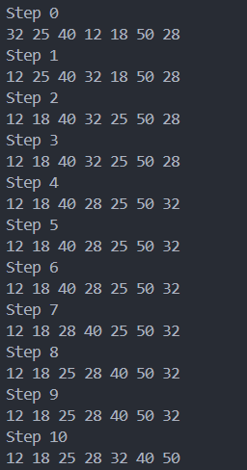

TASK 05

#include <iostream>
using namespace std;

#define N 5

bool isSafe(int maze[N][N], int x, int y) {
return (x >= 0 && x < N && y >= 0 && y < N && maze[x][y] == 1);
}

bool solveMaze(int maze[N][N], int solution[N][N], int x, int y, int destX, int destY) {
if (x == destX && y == destY && maze[x][y] == 1) {
solution[x][y] = 1;
return true;
}
if (isSafe(maze, x, y) && solution[x][y] == 0) {
solution[x][y] = 1;

// Move down
if (solveMaze(maze, solution, x + 1, y, destX, destY))
return true;
// Move right
if (solveMaze(maze, solution, x, y + 1, destX, destY))
return true;
// Move up
if (solveMaze(maze, solution, x - 1, y, destX, destY))
return true;
// Move left
if (solveMaze(maze, solution, x, y - 1, destX, destY))
return true;

solution[x][y] = 0;
}
return false;
}

void setSolution(int solution[N][N]) {
for (int i = 0; i < N; i++)
for (int j = 0; j < N; j++)
solution[i][j] = 0;
}

void printSolution(int solution[N][N]) {
for (int i = 0; i < N; i++) {
for (int j = 0; j < N; j++) {
cout << solution[i][j] << " ";
}
cout << endl;
}
}

int main(){
int maze[N][N] = {
{1,1,1,0,1},
{0,1,0,1,1},
{1,1,1,1,0},
{0,1,0,1,1},
{1,1,1,0,1}
};

int solutionR[N][N];
setSolution(solutionR);
int solutionC[N][N];
setSolution(solutionC);

cout << "Maze Path for Rabbit from (0,0) to (" << N/2 << "," << N/2 << "):" << endl;
if(solveMaze(maze, solutionR, 0, 0, N/2, N/2)){
printSolution(solutionR);
} else {
cout << "No path found." << endl;
}

cout << "Maze Path for Cat from (2,2) to (" << N-1 << "," << N-1 << "):" << endl;
if(solveMaze(maze, solutionC, N/2, N/2, N-1, N-1)){
printSolution(solutionC);
} else {
cout << "No path found." << endl;
}

for (int i = 0; i < N; i++){
for (int j = 0; j < N; j++){
if (solutionR[i][j] == solutionC[i][j] && solutionR[i][j] == 1){
cout << "Intersection at: (" << i << ", " << j << ")";
break;
}
}
}

return 0;
}

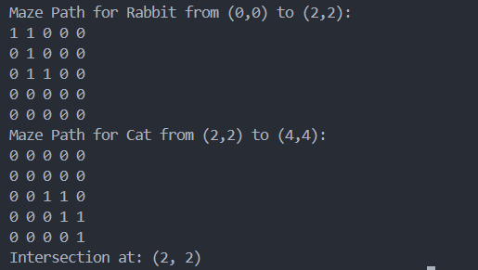

TASK Villagers change finding dilemma

#include <iostream>
using namespace std;

class Node {
public:
int val1, val2;
string data;
Node *next;
Node(int x, int y, string t) : val1(x), val2(y), data(t), next(nullptr) {}
};

class Exchange {
Node *head;
public:
Exchange() : head(nullptr) {
int coins[5][2] = {{2, 4}, {5, 3}, {2, 1}, {2, 2}, {3, 1}};
head = new Node(coins[0][0], coins[0][1], "Villager 1");
Node *curr = head;
for (int i = 1; i < 5; ++i) {
curr->next = new Node(coins[i][0], coins[i][1], "Villager " + to_string(i+1));
curr = curr->next;
}
curr->next = nullptr;
}

void findAndSwapForFive() {
Node *curr = head;
int i = 1;
bool swap = false;
while (curr && !swap) {
if (curr->val1 + curr->val2 == 5) {
cout << curr->data << ": Swapped " << curr->val1 << " & " << curr->val2 << " for 5" << endl;
swap = true;
i++;
}
curr = curr->next;
}
if (!swap){
cout << "No Village has the change! -- BURN THEM ALL" << endl;
}

}

~Exchange() {
Node *curr = head;
while (curr) {
Node *temp = curr;
curr = curr->next;
delete temp;
}
}
};

int main() {
Exchange ex;
ex.findAndSwapForFive();
return 0;
}

